**INTRODUCTION**

This project helps us to know about the characteristics and variations in the 2019 loksabha elections. Also it makes the analysers in curiousity throughout the project .This project also helps to visualize and categorize the future trend in the next loksabha elections.

**PROBLEM DEFINITION AND DESIGN THINKING**

**EMPATHY MAP**

**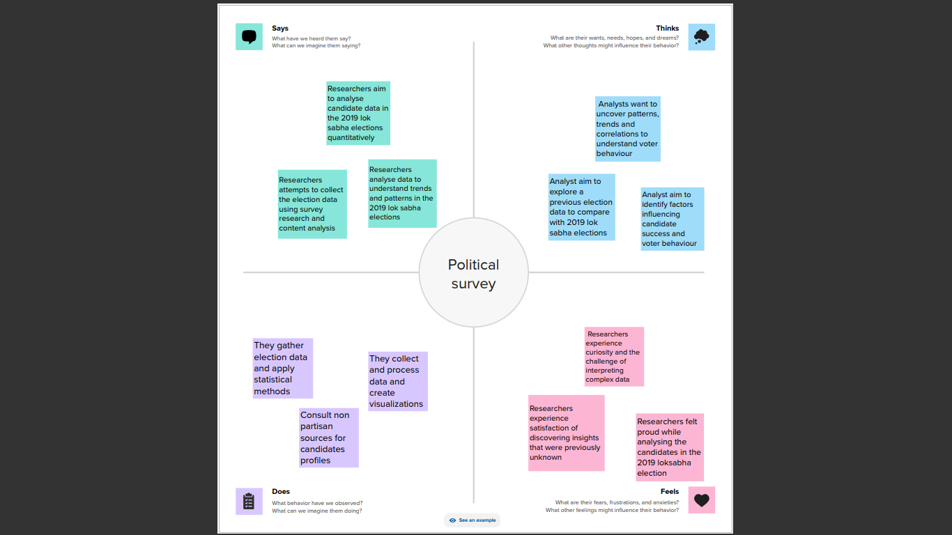  
IDEATION AND BRAINSTORMING MAP**

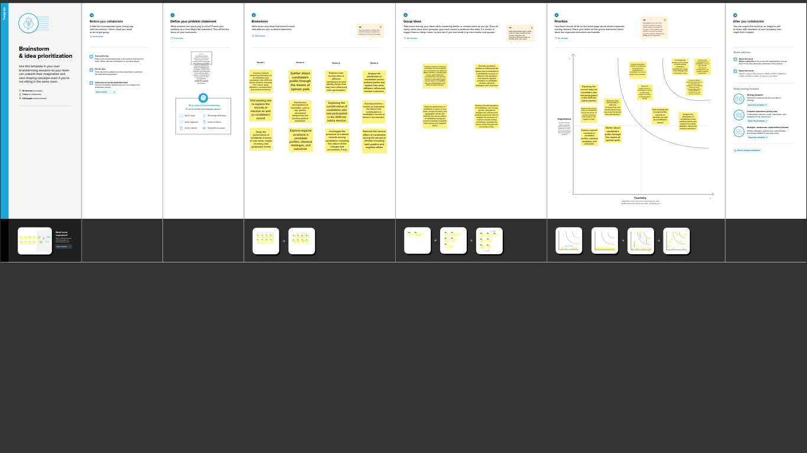

**RESULT**

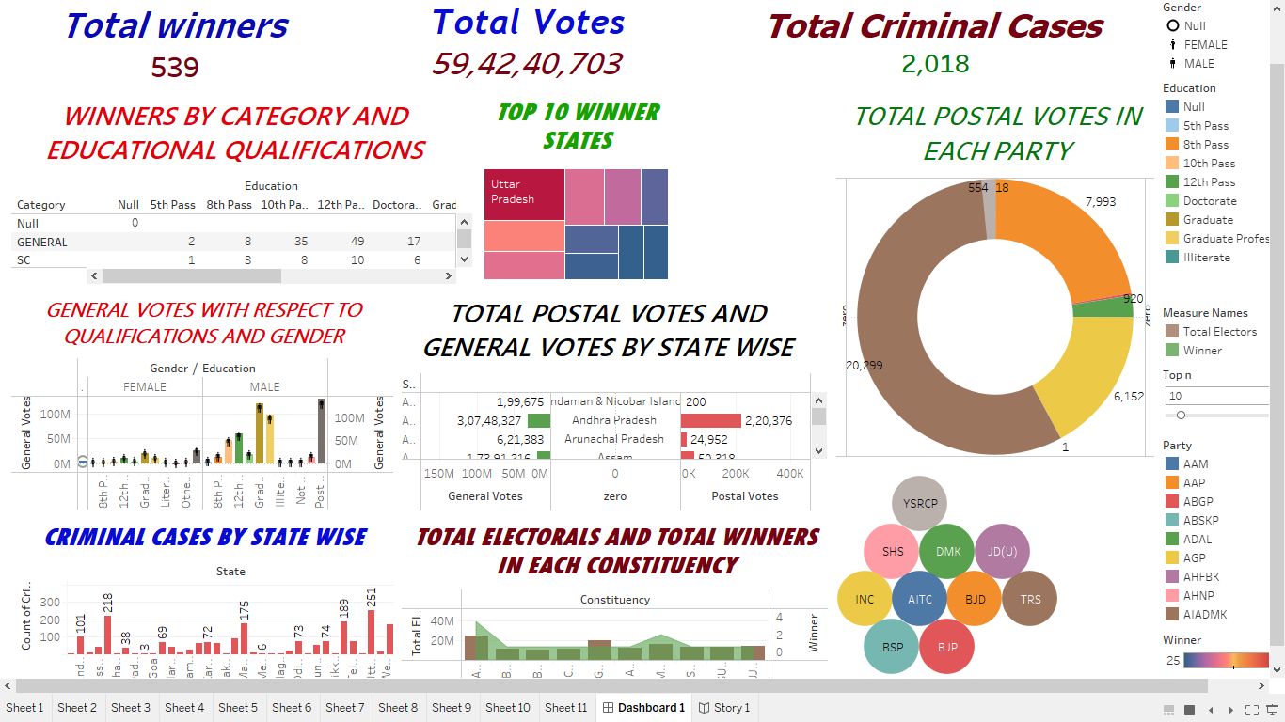

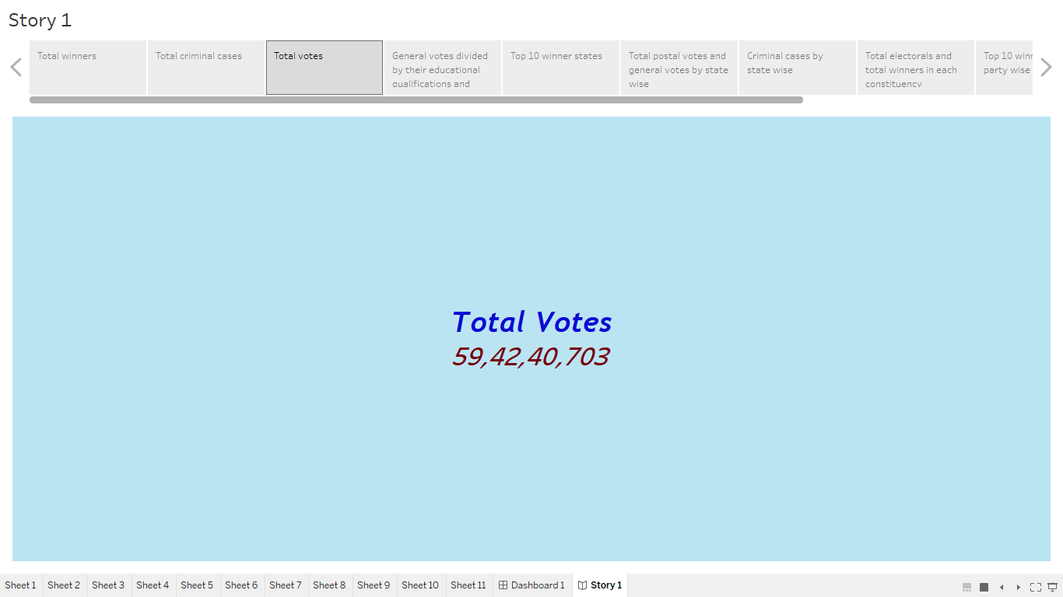

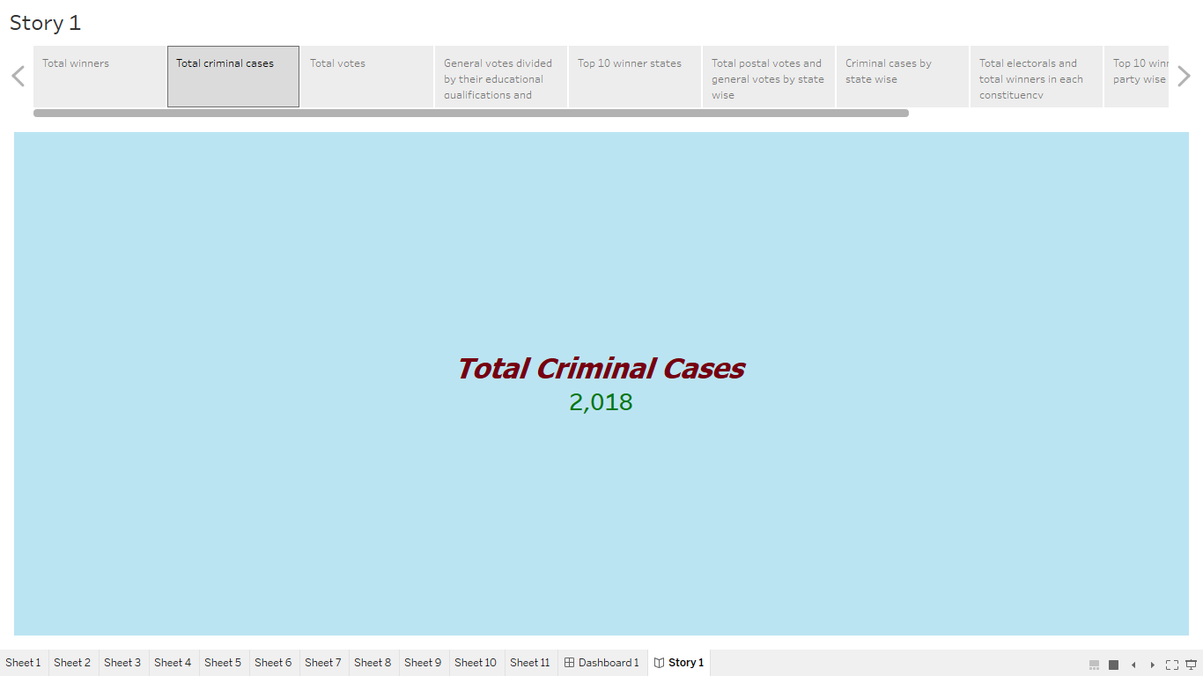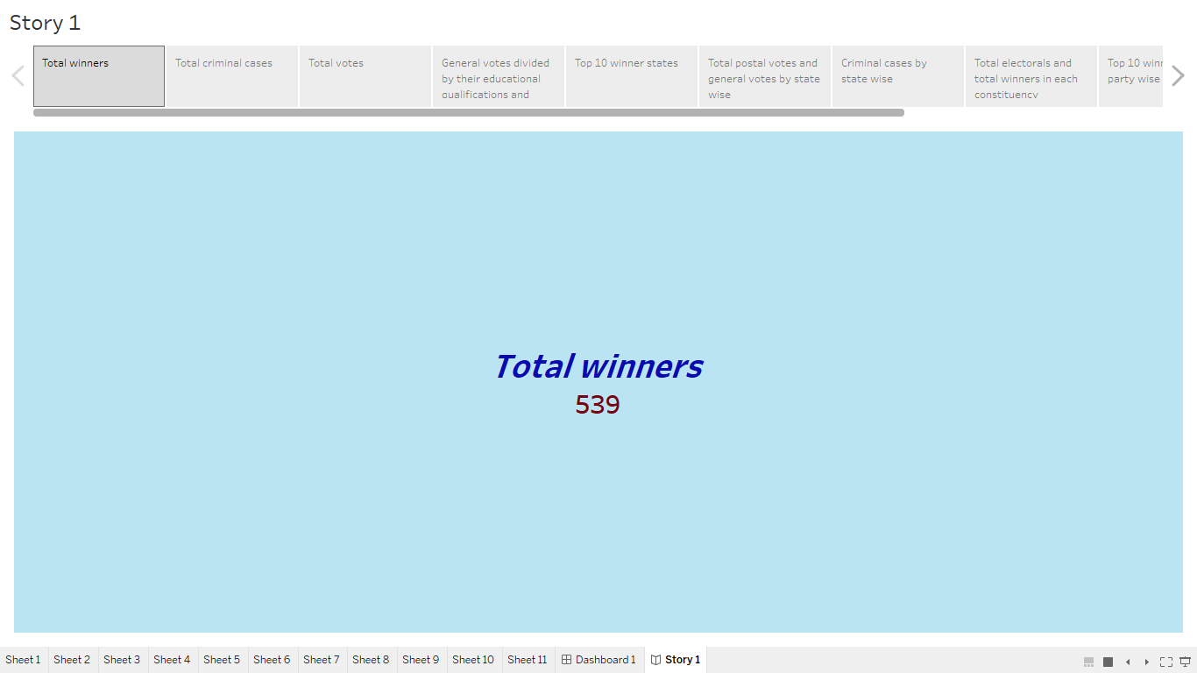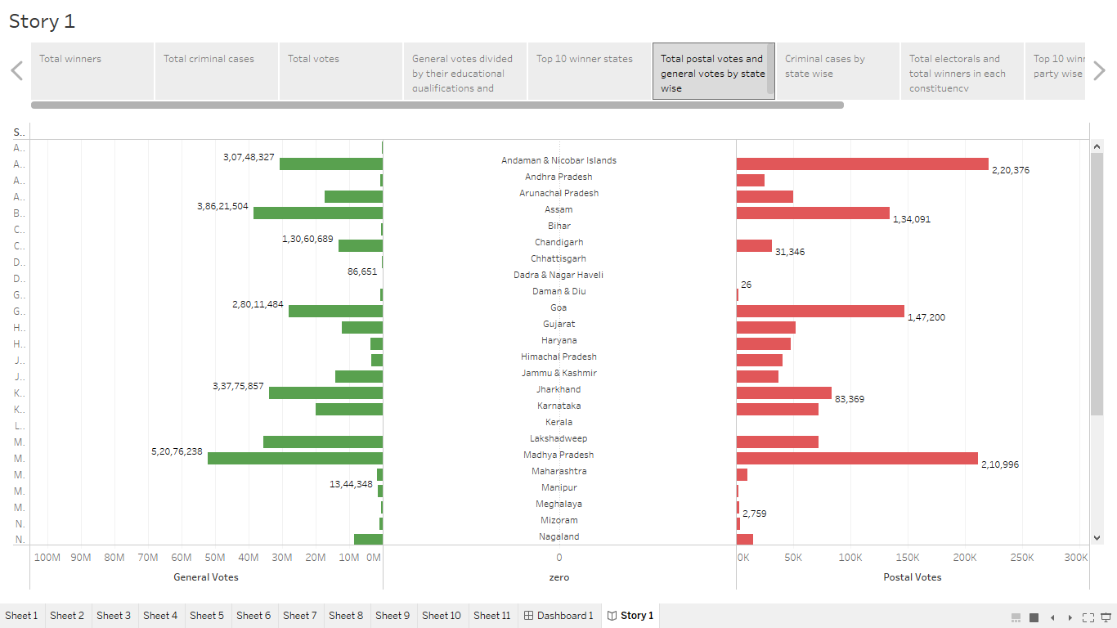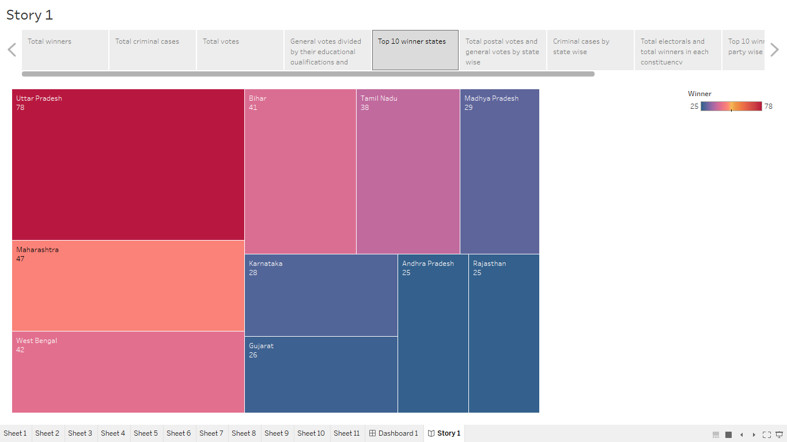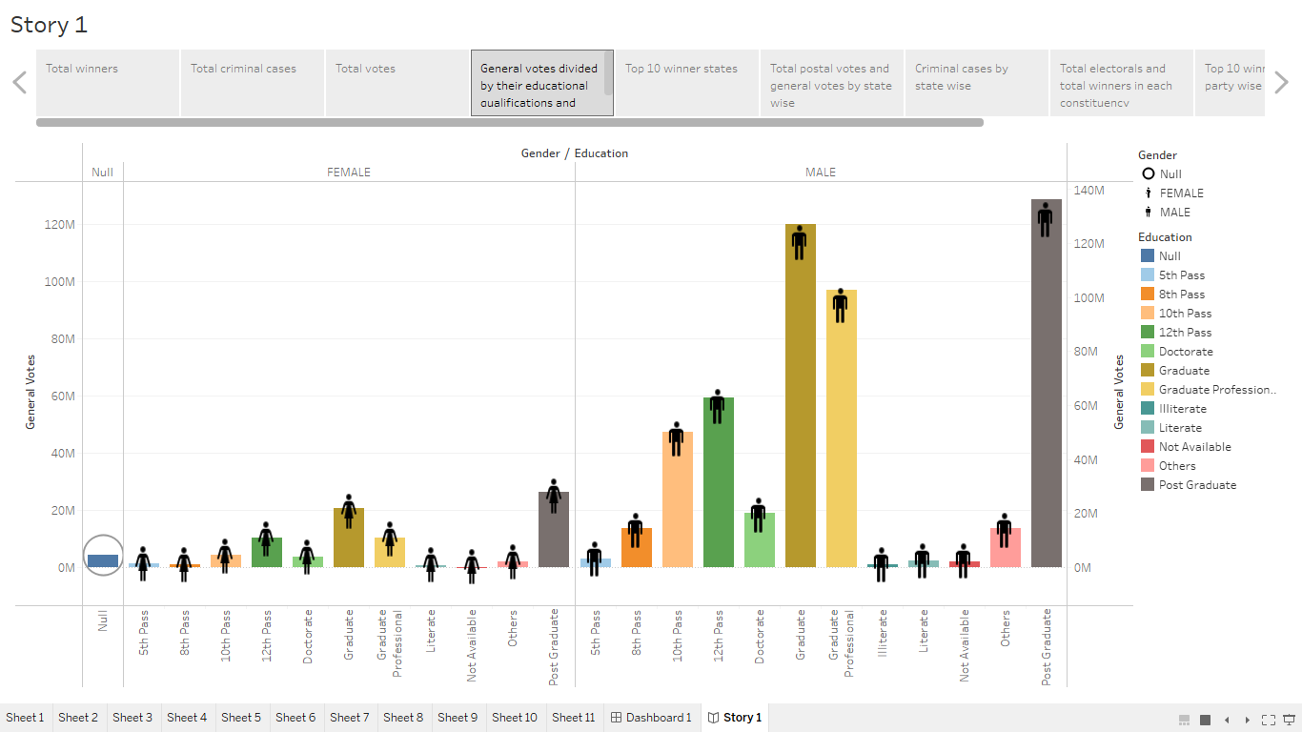

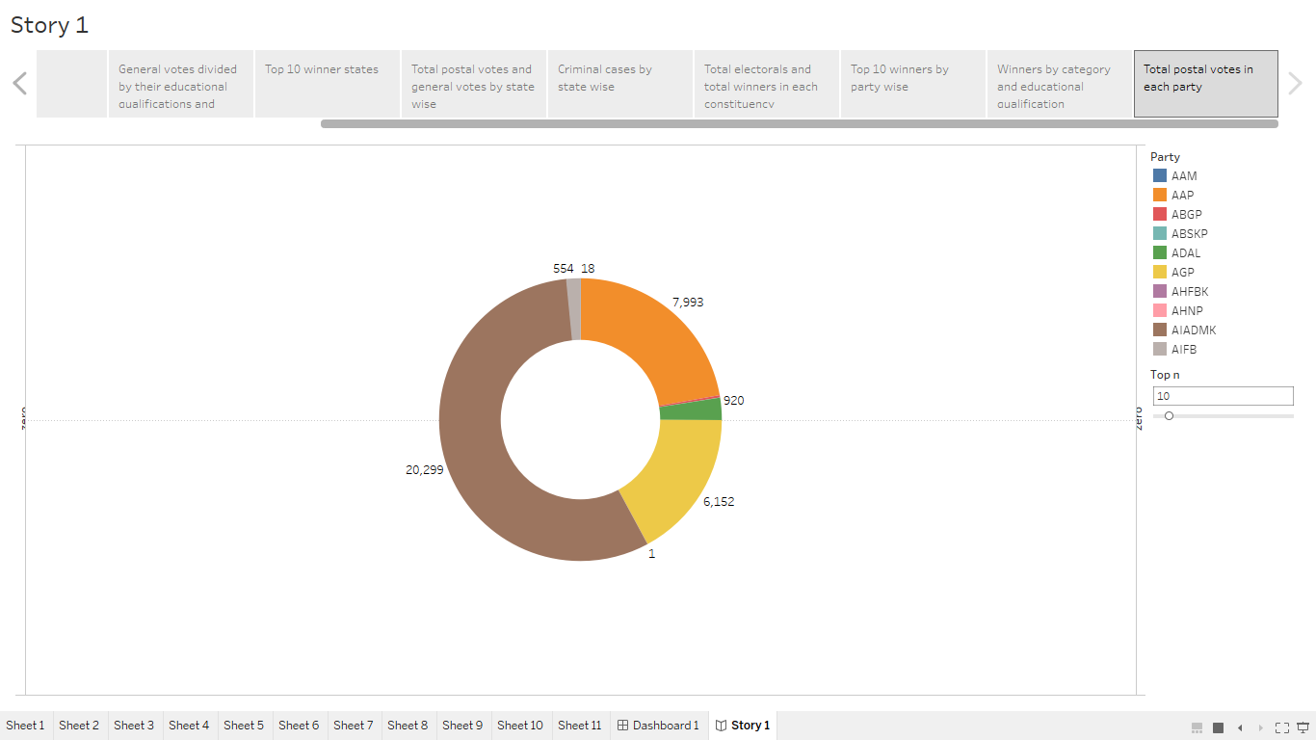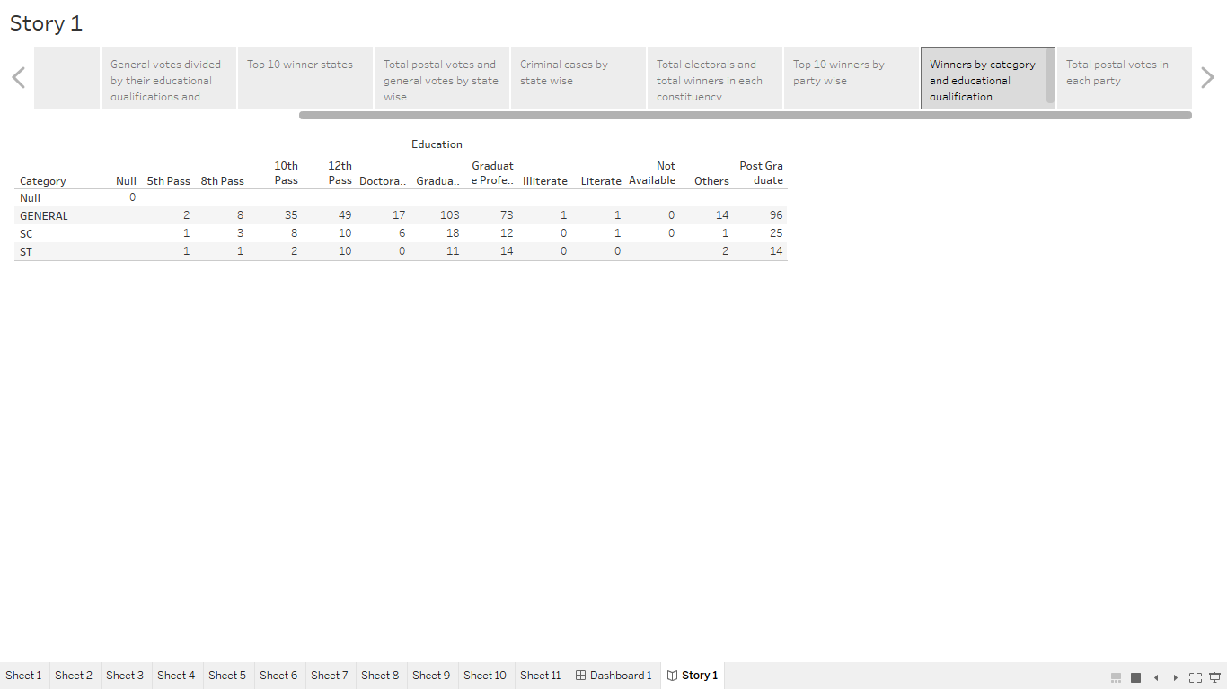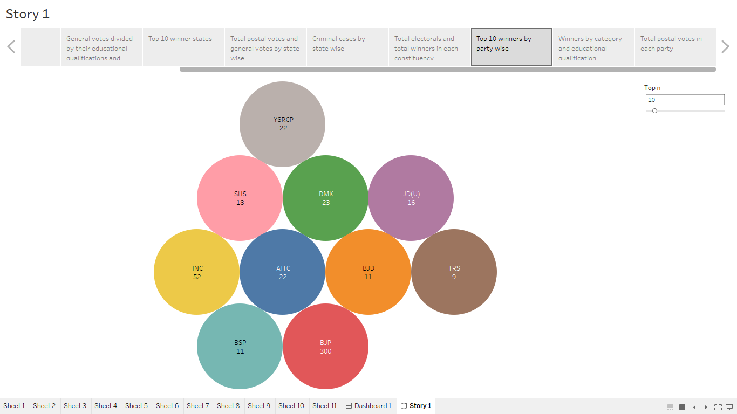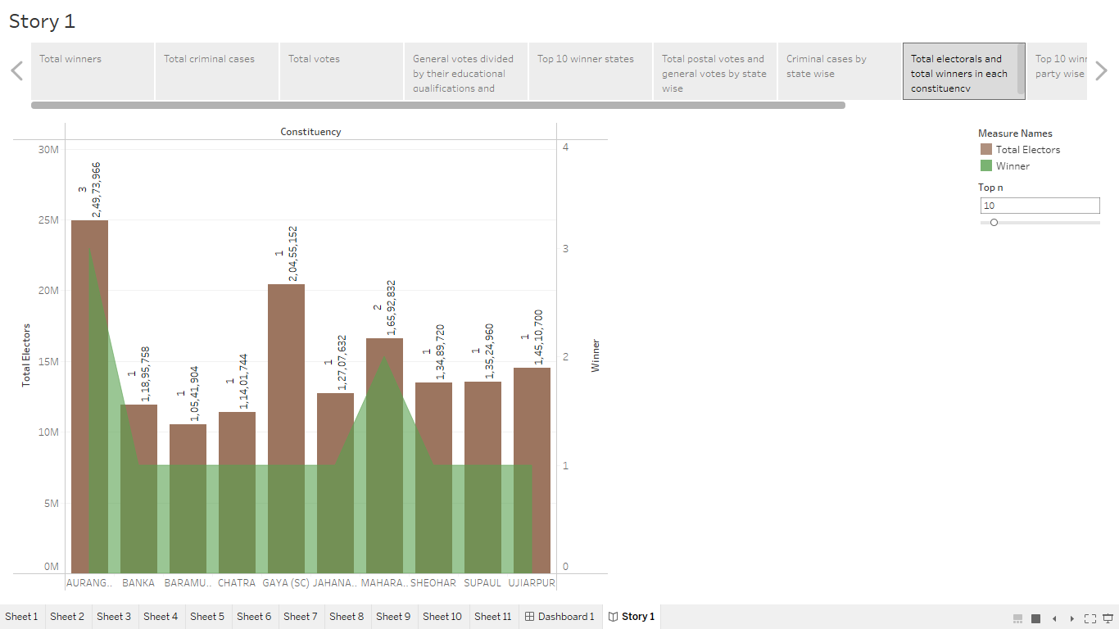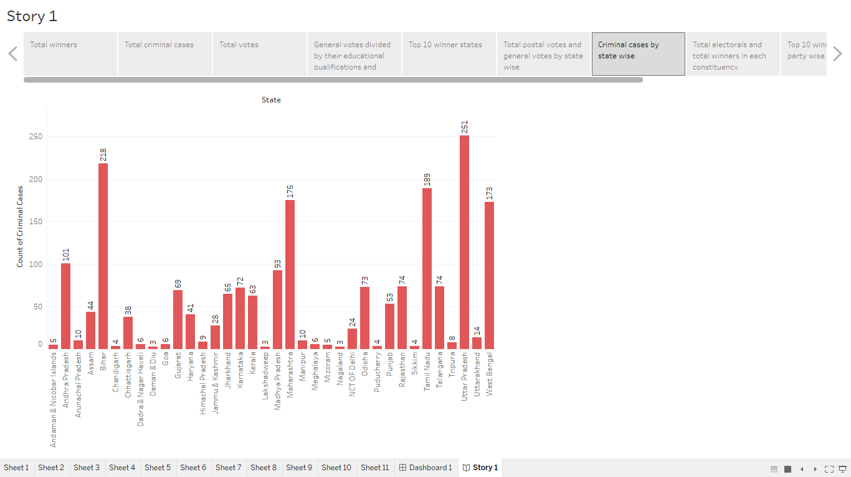

**ADVANTAGES AND DISADVANTAGES OF THE PROPOSED SOLUTIONS**

The main advantage of the proposed solution is that they are easily understandable and they give exact visualization of our problem but the disadvantage is that our proposed solution slightly fail to cover whole analysis of the candidate’s criminal records and electoral performance but we have analysed and proposed them as much as possible.

**APPLICATIONS**

Our solution tends to be a base for future analyses about the 2019 loksabha election.The information about this project should be recorded and noted and also copied in both visual as well as text format fo future generations.It should be distributed all over India since every citizen has the right to analyse about the loksabha elections.

The candidate criminal data helps us to concentrate about that particular crimes and candidates and also makes us to minimize that crimes in future.

If postal votes are significant in number ,then efforts should be taken to improve the equipment for delivering our postal votes.

**CONCLUSION**

The overall project improves our knowledge about the Indian loksabha election and also about the candidate’s qualifications and criminal records.

It gives the information about the total number of votes, criminal cases and winners.

Our project depicts the statewise criminal cases, postalvotes and general votes.Also it visualize the top 10 winner states.

It categorize the general votes based on educational qualifications and gender.

It gives the information about the total electorals and total winners in each constituency.

**FUTURE SCOPE**

Create awareness about elections so as to make the total votes equivalent to our population.

Party wise weightage in each state has been well potrayed.

Efforts should be taken to maximize the femine votes.

Parties can be refreshed and well organised through their implementations and public service after knowing about their electoral data in elections.